JOMO KENYATTA UNIVERSITY OF AGRICULTURE AND TECHNOLOGY



**UNIT: PROJECT**

##### UNIT CODE: BIT 2303

##### COURSE: BSC INFORMATION TECHOLOGY

##### NAME: MUCHERU ALICE NYAMBURA

##### JKUAT NO: BIT- 001-2250/2010

**PROJECT TITLE: ST.FRANCIS HEALTH SYSTEM**

# DECLARATION

I declare that this project is my own idea and my own work. It has not been presented by any other person before and has been developed through my own creation, time and effort.No one else is authorized to use it without my permission.

**Name:** …………………………………

**Signature:** ………………………………

**Date:** **………………………………**

# ACKNOWLEDGEMENT

I would like to express my special gratitude first and foremost to God Almighty for giving me his guidance, grace, wisdom, strength and help throughout the project. Next, I would also like to thank my parents and family for their financial and moral support. I would like to thank my supervisor Mrs Esther Mukoya for her encouragement and persistence. I would also like to thank my friends and colleagues especially Allan Mutimba, Isaac kimani ,Jackson Njuguna and Emily Karanja for their support throughout the project. I would also like to express my sincere gratitude to the staff at St.Francis health clinic without whom this project would not have been possible.

## DEDICATION

I dedicate my project to my parents for their love and support, and to my brothers and sisters for the support

Table of Contents

DECLARATION 2

ACKNOWLEDGEMENT 3

DEDICATION 3

CHAPTER 1: 7

INTRODUCTION 7

1.2PROBLEM STATEMENTS 7

1.3 PROPOSED SOLUTIONS 8

1.4PROJECT OBJECTIVES 8

1.5RESEARCH QUESTIONS 8

1.6METHODOLOGY 9

1.7 JUSTIFICATION 10

1.8RESOURCES REQUIRED 11

HARDWARE 11

SOFTWARE 11

CHAPTER TWO 12

2.0LITERATURE REVIEW 12

ABSTRACT 12

2.1Background. 13

2.2 Introduction 15

2.1.1 Information security 15

2.1.2 Confidentiality 15

2.1.3 Authentication 15

Cryptography 16

TYPES OF CRYPTOGRAPHY 17

2.3 Symmetric encryption schemes. 17

2.4 Asymmetric encryption schemes. 17

2.5Existing systems using cryptography 18

Duke university hospital 18

aghakhan hospital 18

Advantages of cryptography 18

Disadvantages of cryptography 19

2.6 Conclusion. 19

CHAPTER 3 20

3.1SYSTEM ANALYSIS AND DESIGN 20

3.1.1 Introduction. 20

3.2METHODOLOGY 21

3.2.1System analysis 21

3.2.2 System design 21

3.2.3 Object design 21

3.2.4 Implementation 21

3.2.5 Advantages of Object Oriented Methodology 22

3.3FEASIBILITY STUDY 22

3.3.1 Technical Feasibility 23

3.3.2 Economic Feasibility 24

3.3.2.1COST BENEFITS ANALYSIS 24

3.3.3. Operational Feasibility 24

3.3.4 Social Feasibility 24

3.3.5 Legal Feasibility 25

3.4Data collection tools. 25

3.4.1Observation: 25

3.4.2Questionnaires 26

3.4.3Interviews: 26

3.5FUNCTIONAL REQUIREMENTS SPECIFICATION 30

3.6N0N-FUNCTIONAL REQUIREMENTS SPECIFICATION 31

3.6.0EXECUTION QUALITIES 31

CHAPTER FOUR 32

4.0System Design 32

4.1Logical design 32

4.1.1Current system (Sequence) 32

4.1.1.1Proposed System 32

4.1.2Conceptual Entity Relational model 33

4.1.3Use case model 34

4.1.4Class diagram 36

4.1.5ERD and database schema 37

4.2PHYSICAL DESIGN 37

4.2.1 Database schema 37

4.2.2 Input/output screen designs 38

CHAPTER 5. 43

SYSTEM TESTING AND IMPLEMENTATION. 43

5. 1. Testing. 43

5.1.1 Testing process.. 43

*5.2 File Conversion* 43

*5.3 Documentation* 43

*5.4 Changeover Strategy.* 44

5.5 Description of development Environment/tools 44

Programming tools 44

Database tools 44

5.6 Sample Test Data & Error Handling 44

5.6.1Wrong Password Inputs 44

5.6.2 Form Validate 45

CHAPTER 6 47

Appendices 47

questionnaires 47

budget 49

Gantt chart 50

# 

# CHAPTER 1:

## INTRODUCTION

St Francis clinic is a health facility that provides medical services to members of the surrounding community. The facility is run by a team of medical professionals who are fully qualified in their field of professionalism and the sub-ordinate staff. There are five departments in this clinic. Each department though independent in its operation, they work together as a unit to achieve a common goal. The five departments are:

* Reception
* Consultation
* Eye clinic
* Laboratory
* Dental Unit
* Sub-ordinate staff

Each department has a unique “modus operandi” mode of operation that is specific for achieving its set goals. I shall now go into detail for each department.

Achieving its set goals.

## 1.2PROBLEM STATEMENTS

After a study of St Francis Health Services I came to find that the problems it’s facing are;

* Management of patient’s records; managing patients records is quite tiresome as there are many patients and each patient has his/her own file. So with many files patient’s data gets to be so many and papers may pluck off and be mixed with other files.
* Clinic processes are too long; when a patient gets to the reception he/she has to wait for his/her file to be searched for in the file room then he/she is taken their temperature and weight by the nurse. Then he/she is allowed to go to the consultation room to see the doctor and if there is any test to be done in the lab the patient has to wait for a lab request to be filled then he/she can proceed to the lab. By the time the patient has been done with 3 hours or more may be gone.
* Security of files is very minimal. The files maybe edited since they are hand written and stored in files
* Since the clinic is run by one doctor payment is also done at the doctor’s office as at most time the nurse and other workers are busy with other duties.

## 1.3 PROPOSED SOLUTIONS

Would develop an automated system that will ensure that:

1. There is an appropriate security for the patient records and this will be done through authorization, authentication and accounting.

2. Uses of appropriate security when patient information and/or clinical data are transferred electronically

3. Administrative Safeguards and authorization of Information Access Management by implementing policies and procedures authorizing access to electronic patient data.

4. Minimal storage space

5. Quick doctors reference to patience history records.

## 1.4PROJECT OBJECTIVES

* The main objective is to make a system that will be able to manage all the patient’s data and information.
* Second is to be able to reduce the amount of time patients spend in the clinic by implementing a system that will be able to make the processes simple and easy to use.
* Make a system that is user friendly.
* Make a payment system that a cashier can use and no transactions can be lost as it will save all transactions and only the owner can view or print them.

## 1.5RESEARCH QUESTIONS

1. What are the user’s expectations about the system?
2. What are the different types of methods used to test the system?
3. What are the techniques and methodologies used in designing and developing the system?
4. What are the various methods of enhancing accuracy and consistency of the proposed system?
5. What are the methods used to evaluate and test the proposed system?

## 1.6METHODOLOGY

Methodology is a detailed systematic theoretical analysis of the methods applied to a field of study that provides solutions and offers theoretical understanding of which method can be best applied to a specific case and the tools and the general process models are required for the development of the system.

To achieve my objectives, this proposal will use the Object Oriented analysis and design methodology

This methodology is useful because;

1. Risks are usually discovered or addressed during integration.
2. Less time is required for integration as the process goes on throughout the software development.
3. It is flexible, modifiable and adaptable.
4. A good quality system is delivered at the end of the project.
5. Developers can learn along the way, and their various abilities and specialties are more fully employed during the entire lifecycle. Testers start testing early, technical writers begin writing early, and so on.
6. The development process itself can be improved and refined along the way.

UML includes diagrams like-

* Use cases
* Class diagrams
* Entity Relationship diagrams
* Entity relationship model
* Database schema

## 1.7 JUSTIFICATION

. The proposed system would increase efficiency of the Institution by providing effective, efficient and easy to use features.

1. Records would be kept confidential on a safe storage space.
2. Data entry and retrieval will be eased.
3. It would be secure in both terms of data loss and from access of data by unauthorized users.
4. The new system would be less time consuming, easy to use and more reliable.
5. It would reduce the use of paper and data redundancy.
6. It would enhance backup facility for data and make it easy to update ones records.
7. It is more secure - Records will only be accessed by the authorized personnel only

# 

## 1.8RESOURCES REQUIRED

## HARDWARE

* A computer with minimum specification of 2.88 GHz Pentium IV processor, 120GB hard disk, 2GB Ram, with USB ports, mouse , keyboard, and CD writer for carrying out implementation and coding of the proposed system.
* 1GB flash disk for storage of the project and project report.
* Magnetic or optical disk for backups: To have a backup of important information in case of damage.
* Printer with ink cartridges for printing the project report and proposal.

## SOFTWARE

* Operating System Windows 7
* Macromedia Dreamweaver version 8.0
* Macromedia Flash v 8.0
* WAMP Server
* Web browser
* MySQL (relational database management system) RDBMS

# CHAPTER TWO

## 2.0LITERATURE REVIEW

# ABSTRACT

Security is always a major concern when it comes to information systems and more of an issue when the information is being accessed over the network is highly confidential. Such information needs to be kept in a secure manner and be protected from unauthorized access. Cryptography is one form of providing information security that can provide secure communication of information over a network and protect data from unauthorized access.

The project implements Encryption mechanisms to provide authentication, protection of data and securing data being transferred over the network. The researcher investigates the various encryption algorithms like MD5, SHA-1, DSA AES that provide cryptography for encryption, authentication confidentiality.

# 

# 

# 2.1Background.

Kenya’s health care system is structured in a step-wise manner so that complicated cases are referred to a higher level. Gaps in the system are filled by private and church run units. This structure consists of dispensaries and private clinics, health care centres, sub-district hospitals, private hospitals, provincial hospitals and national hospitals. All these hospitals maintain their own private medical records of patients given care. Gaps in the system are filled by private and church run units. this structure consists of dispensaries and private clinics, health

Although technological advancements in science have greatly improved medical care in recent decades improvement in the management of patient information have been languid. Many of these health care institutions continue to rely on paper based medical records as the primary source of patient medical and demographic information.

Paper medical records have their disadvantages; they are easily lost and damaged, they are often incomplete, they can disappear during emergencies, can have correct or incorrect information, doctors end up duplicating tests or making uninformed decisions and they can delay care due to miscommunication, lost or destroyed records.

Information on patients’ medical history should be accurate and immediately available to individuals involved in the care of patients. This calls for the need for a centralized patient information repository. That would support the Use of electronic medical records for all health care institutions. This will provide the ability to capture, organize and present relevant clinical information about a patient, in which ever hospital he/she is. It will allow all care givers to access their medical records at any time. When there exists defined protocols for treatment of some diseases, it would be easier to monitor treatment closely for both clinical and research purposes.

In review of this, information needs to be kept in a secure manner and to protect it from unauthorized access. The researcher intends to research on the methodologies designed for enforcing information security; especially on the role of cryptography in providing secure communication of confidential information over the network, and protecting data unauthorized access.

Objectives

1. To find out how best to combine security mechanisms to come up with more secure applications.
2. To develop a system that will be able to manage all the patient’s data and information.
3. To be able to reduce the amount of time patients spend in the clinic by implementing a system that will be able to make the processes simple and easy to use.
4. Make a payment system that a receptionist can use and no transactions can be lost as it will save all transactions and only the owner can view or print them.

Research questions

1. What are the user’s expectations about the system?
2. What are the different types of methods used to test the system?
3. What technologies exist for use in developing a cryptographic health system?

## 

## 2.2 Introduction

This literature review introduces and defines concepts relating to cryptography, cryptographic protocols, encryption and general concepts about information security. Cryptography is the discipline of ensuring that messages are secure from possible attacks. In this literature review the researcher intends to discuss some cryptographic principles and algorithms. Cryptographic protocols are vital components of information security, as a mean of securing communication over networks. In this literature review there are various cryptography principles and algorithms.

### 2.1.1 Information security

Information security “means protecting information and information systems from unauthorized access, use, disclosure, disruption, modification, perusal, inspection, recording or destruction.” (Information_security, 2012)Information security is the process by which an organization protects and secures its systems, media, and facilities; that process and maintain information vital to its operations. The value of information comes from the characteristics it possesses. When a characteristic changes, the value of that information either increases or decreases. Model of information security evolved from a concept

### 2.1.2 Confidentiality

Confidentiality is “Preserving authorized restrictions on information access and disclosure, including means for protecting personal privacy and proprietary information…” (FIPS PUB 199, 2004). Confidentiality also refers to limiting information access and disclosure to authorized users and preventing access by or disclosure to unauthorized ones. Unauthorized access to confidential information may have devastating consequences, not only in national security applications, but also in commerce and industry. Main mechanisms of protection of confidentiality in information systems are cryptography and access controls. Examples of threats to confidentiality are malware, intruders, social engineering, insecure networks, and poorly administered systems.

### 2.1.3 Authentication

Authentication is the act of establishing or confirming something (or someone) as authentic, that claims made by or about the thing are true. Authentication of an object may mean confirming its provenance. Authentication of a person often consists of verifying their identity. In computer security, authentication is the process of attempting to verify the identity of the sender of a communication such as a request to log in. The sender being authenticated may be a person using a computer, a computer itself or a computer program. In a web of trust "authentication" is a way to ensure users are who they say they are that the user who attempts to perform functions in a system is in fact the user who is authorized to do so

## Cryptography

Cryptography is a “method of storing and transmitting data in a form that only those it is intended for can read and process. It is a science of protecting information by encoding it into an unreadable format. Cryptography is an effective way of protecting sensitive information as it is stored on media or transmitted through network communication paths.” (HarrisX, 2001)

Cryptography is not a recent science, but an old strategy to guarantee information exchange security. It covers from data encryption and decryption, digital signature to hash function and more. Encryption and decryption are the two main functions in cryptography system. Encryption is the transformation of data into a form unreadable by anyone without secret key in order to ensure privacy. The information is hidden from anyone for whom it is not intended, even from those who can see the encrypted data. Encryption also allows secure communication over an insecure channel especially Internet. Decryption is the reverse function to retrieve the original encrypted messages using secret key.

* There are in general, there types of encryption schemes used in cryptography; symmetric cryptography, asymmetric cryptography and hash functions. This classification is based on the number of keys employed in encryption and decryption. Symmetric cryptography uses a single key for both encryption and decryption, asymmetric cryptography uses one key for encryption and another for decryption, hash functions use mathematical transformations to irreversibly encrypt information. According to Schneider. (1996). *Applied Cryptography.* London: London press. Cryptography is the discipline of ensuring that messages are secure from possible attacks. Cryptography is the use of mathematics in science to protect data.

# TYPES OF CRYPTOGRAPHY

## 2.3 Symmetric encryption schemes.

Symmetric cryptography, also known as secret key cryptography, the key is shared between the two communicating parties. The two parties must agree on the key beforehand and communicate it to each other. A user ***A*** sends the secret private key *K* c to a ***B*** user before the start of the communication between them. Both sides use the same private key to encrypt and decrypt the exchanged information. Data Encryption Standard (DES) and CAST128 are examples of symmetric key algorithm.

## 2.4 Asymmetric encryption schemes.

In an asymmetric key algorithm, there are two keys. One must be public and it is used to encrypt the data. The other key is a private one and it is used to decrypt the information. When two parties *A* and *B* want to communicate *A* uses the public key *Ke* of **B** to encrypt the message, in a way that only **B** can decrypt this message using his private key *Kd*. This system is also used to sign a message digitally (Mao, 2003). Examples of asymmetric key algorithms are Rivets-Shamir-Alderman (RSA), Megamall, DES etc.

Cryptography is used to achieve the following goals:

1. **Confidentiality**

To ensure data remains private. Confidentiality is usually achieved using encryption. Encryption algorithms (that use encryption keys) are used to convert plain text into cipher text and the equivalent decryption algorithm is used to convert the cipher text back to plain text. Symmetric encryption algorithms use the same key for encryption and decryption, while asymmetric algorithms use a public/private key pair.

**2. Data integrity**

To ensure data is protected from accidental or deliberate (malicious) modification. Integrity is usually provided by message authentication code or hashes. A hash value is a fixed length numeric value derived from a sequence of data. Hash values are used to verify the integrity of data sent through insecure channels. The hash value of received data is compared to the hash value of the data as it was sent to determine if the data was altered.

**3. Authentication**

To assure that data originates from a particular party. Digital certificates are used to provide authentication. Digital signatures are usually applied to hash values as these are significantly smaller than the source data that they represent.

## 2.5Existing systems using cryptography

## Duke university hospital

It uses a type of cryptography called IDEA. The International Data Encryption Algorithm (IDEA) is a symmetric-key, block cipher, published in 1991 by Lai Massey and Murphy [3]. IDEA encrypts a 64-bit block of plaintext to 64-bit block of cipher text, using a 128-bit key. The algorithm consists of eight identical rounds and a “half” round final transformation. IDEA uses algebraic operations to encrypt data;

## aghakhan hospital

They use a type of cryptography called RSA algorithm “named after Ron Rivets, Adin Shamir and Len Alderman, who invented it in 1977” (David Ireland, 2002). It can be used to encrypt a message without the need to exchange a secret key separately. Its security is based on the difficulty of factoring large integers.

## Advantages of cryptography

* It hides the message and your privacy is safe.
* it is used to protect critical data from being accessed by hackers.
* It can be used to decrypt or decode processes as well in order to gain access to necessary information.
* No one would be able to know what it says unless there's a key to the code.
* You can write whatever you want and however you want (any theme any symbol for the code) to keep your code a secret.

## 

## Disadvantages of cryptography

* In one way or another key encryption has to be shared.
* Causes more damage if compromised. If someone gets your key they can easily change it.
* Cryptography itself is very expensive to implement since it requires huge memory to store huge chunks of data and skilled personnel to care for it.

## 

## 2.6 Conclusion.

In this Literature Review there is more exploration on the major concepts behind cryptography used in this research. It is important to acknowledge that cryptography can still be vulnerable to attacks hence this demonstrates the importance of considering the overall security of a system, as opposed to treating encryption as a separate function in the system.

# CHAPTER 3

## 3.1SYSTEM ANALYSIS AND DESIGN

## 3.1.1 Introduction.

Analysis is a step in system development that is concerned with detailed investigation by the system developer, by first studying the existing system, then using the information gathered to define the requirements of the new system.

System analysis or requirement analysis is the problem that the organization will try to solve in the software system. It consists of defining the problem identifying, specifying the solution and identifying the information requirement that must be met by the software system solution.

**Why Analysis?**

Analysis being a process for identifying and solving problems, it involves breaking the proposed system down into its parts so that the whole may be understood. Going ahead to design phase without deeply analyzing and clearly understanding the system could lead to serious errors. Again, it’s worth emphasizing that a mistake or missed requirement from the analysis phase may cost much more money to fix later than if it had been caught in the analysis phase.

Analysis is done with intent of improving the system through better procedures and methods. When the system is investigated, analysis will find more weaknesses in it. Moreover, analysis is also done to develop information systems to meet new information or operational needs.

## 3.2METHODOLOGY

Object oriented analysis and design methodology takes objects as its basis and for the proposed system to be developed using java platform, it has to be observed and requirements defined. Once this is done, the objects in the system are identified through object modeling and their interrelationships. The coding of the system begins as it follows a sequential process of system designing approach. The basic steps of object oriented analysis and design are as follows;

## 3.2.1System analysis

This phase involves interacting with user of the system to find out the user requirements and carryout analysis of the system to understand the functions. Based on system study, I will prepare models of the desired system. This model will be purely based on what the system requires to do as the system is made up of a set of interaction objects like the use of use cases and data flow diagram.

### 3.2.2 System design

In this stage the overall architecture of the desired system will be decided. The system will be organized as a set of subsystem interacting with each other.

### 3.2.3 Object design

Under object design, the details of system analysis and design are implemented. The objects that I will have identified in the system design are constructed, and these objects will be decided and data structures are defined and also interrelationships between objects are constructed.

### 3.2.4 Implementation

During this phase, the class objects and the interrelationships of these classes will be translated actually coded using java programming language. The databases will be made and the complete system will be given a functional shape.

### 3.2.5 Advantages of Object Oriented Methodology

* Object Oriented Methodology closely represents the problem domain. Because of this, it is easier to produce and understand designs.
* The objects in the system are immune to requirement changes. Therefore, allows changes more easily.
* Object Oriented Methodology designs encourage more re-use. New applications can use the existing modules, thereby reduces the development cost and cycle time.
* Object Oriented Methodology approach is more natural. It provides nice structures for thinking and abstracting and leads to modular design.

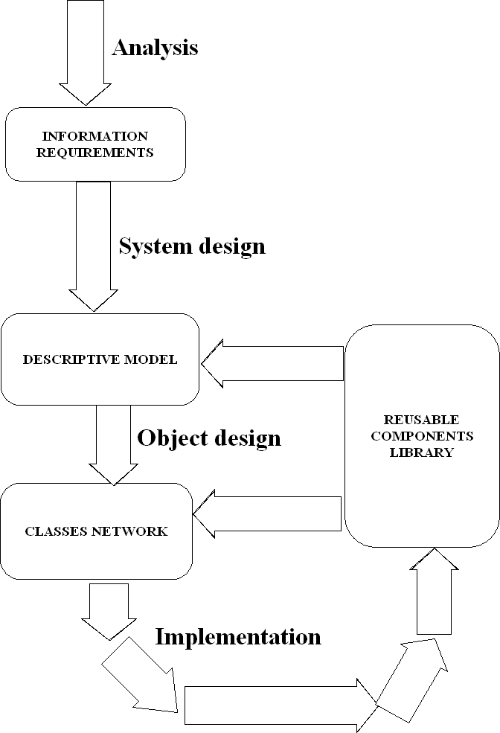

#### Figure 3: object oriented analysis and design

# 3.3FEASIBILITY STUDY

This is a study aimed at finding out whether the system is viable or not, carried out to make sure that the new system would be efficient to the clinic once implemented. It is concerned with analyzing the available technology, system operation and use of the available funds for the project. The feasibility study was done during several visitations to the clinic to find out how the office carried out its operations. During the study, it was realized that the clinic faced several problems with the current system.

A feasibility study was carried out on the following areas in order to determine the viability of the project.

## 3.3.1 Technical Feasibility

During the research, it was noted that there was lack of enough hardware, software and skilled personnel to operate and maintain the system. It was also noted that the available software and hardware devices were outdated. The management was therefore required to purchase new computer systems and the staff would be trained freely on computer skills in order to be in a position to operate them.

Figure 4 Chart 2: Staff’s Response on Technical Viability of the new system

With majority of the staff approving the system as technically viable, its development was approved.

## 3.3.2 Economic Feasibility

This was also carried out by comparing the cost of developing, operating and maintaining the proposed system against rate of returns to find out whether the costs to be incurred in the development of the new system would be justified by the benefits.

## 3.3.2.1COST BENEFITS ANALYSIS

* To reduce record costs and office operational costs.
* Increasing processing efficiency thus improving professionalism
* Leading to client satisfaction and goodwill.

## 3.3.3. Operational Feasibility

This feasibility study method was carried out to check whether the new system conforms to the normal ways that the clinic ran their work and ascertain whether the system was user friendly hence acceptable to the new users. The new system is just an improvement of the old system into a new format that is automated thus conforming to the normal operations of the organization.

With all the advantages coming with the new system, 80% of the staff members believed that the system would be viable operationally, 13% felt the opposite while only 7% of the members were not sure. Given that a good number of the staff members were positive that a new system would conform to the normal way the clinic ran their work, the operational study was deemed viable.

## 3.3.4 Social Feasibility

This was based on the acceptability of the system by users. It dealt with the willingness and ability of the staff to accept the proposed system. A number of the staff members are computer literate except for a few who feared that since they did not have computer skills, the introduction of a new system would displace them. Some of these employees were relieved by the fact that the organization planned to offer a free training to its staff on the new system to enable them fully operate the new system without any difficulties. The staff was impressed by the information of the introduction of a new system. They readily welcomed the fact that a free training was in store for them and that the new system would not only be easy to operate but would ease their work a big deal.

## 3.3.5 Legal Feasibility

This study method was carried out to find out whether the new system abides by the laws, rules and regulations, which should not be violated. The possibility of displacing some of the workers posed a great risk if they decided to file cases against the organization; however, this relied on what legal factors had to be imposed. Nevertheless, the new system was granted a go ahead.

# 3.4Data collection tools.

## 3.4.1Observation:

Observation was used as a data collection tool in the health clinic. There was preparation to visit the employees.

*Advantages of observation*

* Data gathered were highly reliable
* I was able to see exactly what is being done
* Its relatively inexpensive
* Complex operations that are not easily explainable can be understood through observation.

**Disadvantages of observation.**

* People may feel uncomfortable when being observed
* Some systems activities may take place at odd times causing a scheduling inconveniencies for the system analyst.
* The tasks being observed are subject to various types of interruptions.

### 3.4.2Questionnaires

Questionnaire was prepared on a form for the employees. The questions were well formulated according to the system in focus.

**Advantages of questionnaires**

* It is free from interviewer distortion and error
* They save time in data collection
* They avoid biasness
* Data can be collected from a large sample.
* Questionnaires allow individuals to maintain anonymity. Therefore individuals are likely to give more honest answers

**Disadvantages of questionnaires**

* Low response rates
* Someone can complete the questionnaires from the study of the response
* It can only be used by literate people
* They are incomplete i.e. no clear reason can be given
* Lack of direct contact with the analyst may mean that questions are interpreted in different ways. There is no opportunity to clarify ambiguities.
* Prone to exaggerations and abuse.
* Expensive in large populations.

##### A sample of questionnaire prepared

There was preparation of a questioner and gave it to the health clinic management. The questionnaire was divided into two parts the first part of questions was open answer questions while the second part was closed answer questions. They mainly addressed the current management system. A sample of the questionnaire that I prepared is as follows in the appendices.

## 3.4.3Interviews:

Questions were asked to the employees of the clinic about the problems they were experiencing with the new system and what requirements they would like in the proposed system.

This can be done face to face, through telephone or over the internet. This is conducted to achieve the following:

* Finding facts.
* Verifying facts.
* Clarifying facts.
* Identify requirements
* Generate enthusiasm.

In this case I interacted with organization employees to gather information.

**Advantages if interviews.**

* High response rate
* Provides instant feedback.

**Disadvantages of interviews.**

* It’s expensive
* Its time consuming
* Data collected may be difficult to analyze
* It requires high level of skill

#### Report from the questionnaire & interviews

**Would you prefer a health automated System?**

|  |  |  |
| --- | --- | --- |
| Responses | Total number of respondents | Percentage number of respondents (%) |
| Yes | 42 | 84 |
| No | 4 | 8 |
| Not Sure | 4 | 8 |
| Total | 50 | 100 |

Table 1

Fig 1

**Have you ever interacted with the health System before?**

|  |  |  |
| --- | --- | --- |
| Responses | Total number of respondents | Percentage number of respondents (%) |
| Yes | 30 | 60 |
| No | 20 | 40 |
|  |  |  |
| Total | 50 | 100 |

Table 2

Fig 2

**In your opinion, do you think the proposed system will be of value to you?**

|  |  |  |
| --- | --- | --- |
| Responses | Total number of respondents | Percentage number of respondents (%) |
| Yes | 45 | 90 |
| No | 2 | 4 |
| Not sure | 3 | 6 |
| Total | 50 | 100 |
|  |  |  |

Table 3

**Fig 3**

**In your view, will the proposed system affect the standard academy fees?**

|  |  |  |
| --- | --- | --- |
| Responses | Total number of respondents | Percentage number of respondents (%) |
| Yes | 48 | 96 |
| No | 1 | 2 |
| Not sure | 1 | 2 |
| Total | 50 | 100 |

Table 4

Fig 4

## 3.5FUNCTIONAL REQUIREMENTS SPECIFICATION

1. Be able to capture and input the patients, nurses and doctors details
2. Assign rights and permissions to the users of the software to ensure security by use of passwords.
3. Provide a database system where all records will be stored for retrieve and view of records with ease.
4. Provide a faster means of searching the patients, nurses and doctors details

## 3.6N0N-FUNCTIONAL REQUIREMENTS SPECIFICATION

### 3.6.0EXECUTION QUALITIES

#### 3.6.0.1SECURITY

It addresses data security, access security and information security. It also addresses any other option or path to follow in case of flows e.g. backups. Authentication, back up and validation of task grouped according to user domains helps ensure this.

#### 3.6.0.2REUSABILITY

The system is designed with multiple options and the end user management. It comes with management system that will allow the end user to backup, delete old information or store data in large storage areas. It uses functions that can be reused in different growth areas with ease of adding one’s own code to cater for their needs.

#### 3.6.0.3 ACCESIBILITY

The doctors can access the website easily and access the records.

# 

# CHAPTER FOUR

## 4.0System Design

## 4.1Logical design

### 4.1.1Current system (Sequence)

Figure : Current System Sequence Diagram

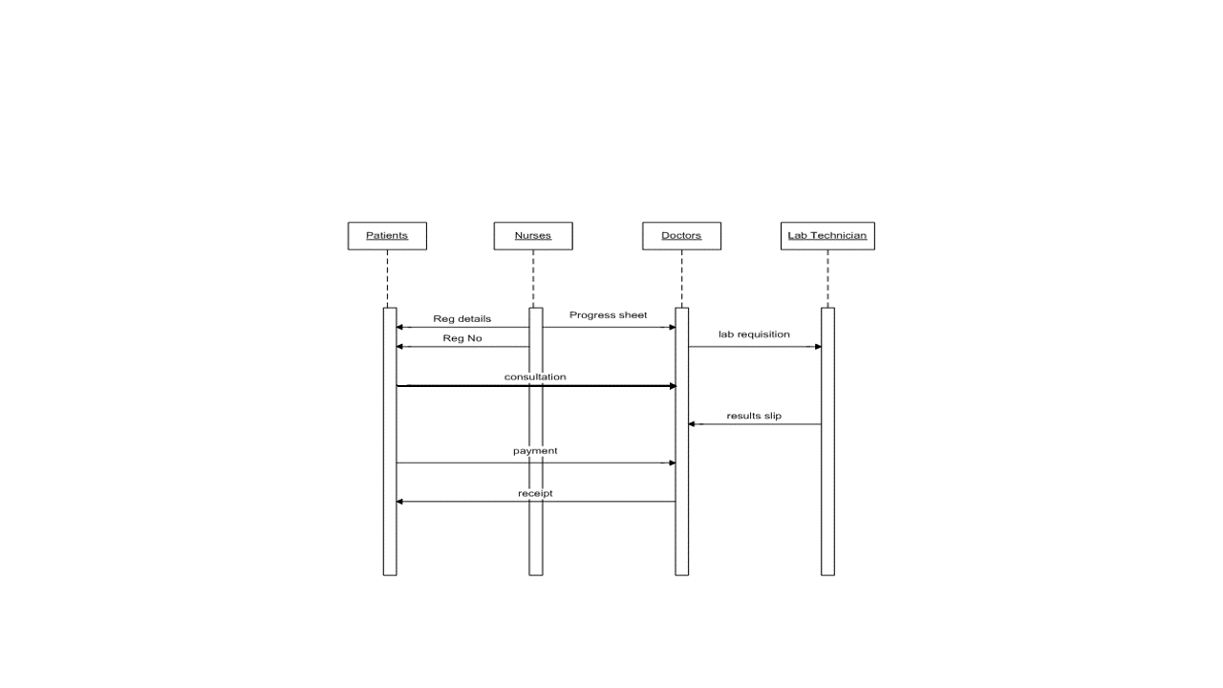

## 4.1.1.1Proposed System

**figure 2: Proposed System Sequence Diagram**

### 

### 4.1.2Conceptual Entity Relational model

Patient

Nurses

Consultatioon

1: M

1: M

1: M

1: M

1: M

Labsreqs

Payment

Doctors

Figure 3: Conceptual ERM

### 4.1.3Use case model

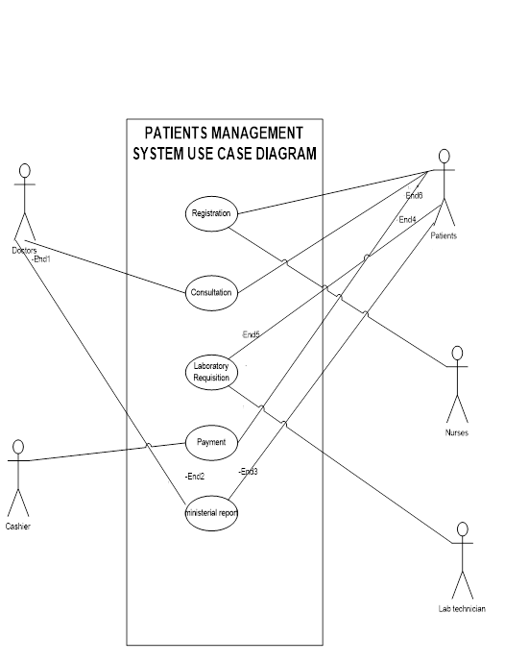

Figure4: A use case model

Use case diagrams are used to depict a general overview of the flow of activities of the system

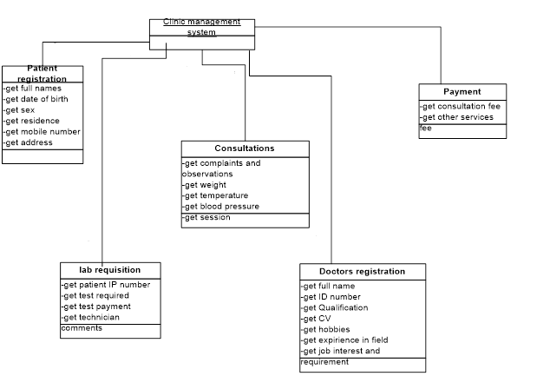

## 4.1.4Class diagram



Figure5: System Class Diagram

### 4.1.5ERD and database schema

## 4.2PHYSICAL DESIGN

### 4.2.1 Database schema



Table : Database schema

## 4.2.2 Input/output screen designs

**The Patient Registration module**

Residence

Telephone

Address

Gender

Date of birth

FUll Names

Registration No

ID Number

Save

Update

Cancel

Figure : Patient Registration

The Patients Registration module enables for the registration of new patients into the system.

The Patients Registration module enables for the registration of new patients into the system.

The update button allows one to change patient details after he has been registered. It only alters the patient row and not make a new record.

**Doctors Registration**

Full Names

qualification

Job interest

Telephone



Presented CV

Strength and weakness

Date

Presented CV

Figure : Doctors Registration Screen

Cancel

Update

Register

**This** module allows the doctor to register and the system will automatically generate a doctors number for the doctor. The doctors number is a unique primary key and each doctor will have his own.

The update button allows one to change Doctors details after he has been registered. It only ulters the Doctors row and not make a new record.

**Lab Requisition**

The Lab Requisition module allows the doctor to ask for a test. Once he/she fills in the details for the test he wants done he/she sends it to the lab. The lab technician finds it as a pop up menu and also can retrieve the tests ordered for from the database.

A doctor can ask for more than test.

Name

Patient Number



Specimens



Test Required

Doctors Number

Date

Delete

Send to lab

Figure :Lab Requisition Module

**Reports Generator module**

Patients

Consultations

Lab Reqs

Payments

Exit

Print

Figure : Reports Module Screen

Thereport generator module allows one to print a report of the details saved in the database in either a table or a text area.

It will print it in a Adobe Pdf, Word Document, One Note 2007 and Microsoft XPS document creator.

**The login module**

The log in module allows the registered staff members to login to the system. Each staff member has is own username and password. The nurse cannot login to the consultation or payment module as she/he are only allowed to register patients. The cashier can only login to the payment module. The lab technician can only login to the lab requisition module. The doctor can login to the consultation module and the report generator module.

Cancel

Login

Password

Username

Figure : Login Module Screen

# CHAPTER 5.

## SYSTEM TESTING AND IMPLEMENTATION.

This involves those processes aimed at ensuring that the system meets is requirements and specification and that the system is properly installed and implemented.

## 5. 1. Testing.

This is the testing of the programs to check for errors and bugs and also to ensure that the software meets the required specification/functionality.

### 5.1.1 Testing process..

The testing process that was used involved:-

* unit testing

This involves testing of individual forms to ensure correctness. Each form is tested independently.

* Module testing

This is testing of individual program components. A module (form) is a collection of related components (procedures, functions). The module performs a sub function of the system .the module’s components are tested together to ensure correctness of that sub function.

* System testing

The purpose of the system testing is to use the system in a controlled test environment, but to do so as the user would use the system in production environment. The system test should demonstrate that the complete system would do what it is supposed to do in the user environment.

* Acceptance testing

The system is tested with data from the customer .it may reveal errors and omissions that were not found when using simulated test data. It may also show requirement problems where the system does not really meet the requirements.

## 

## *5.2 File Conversion*

This involves the transfer of data from format to another i.e. from the current system the new system. The data that is currently held in paper files and folders will require to be transferred to computer system. This will be as the current system is in use and the new system will use the data entered as it arrives.

## *5.3 Documentation*

There are two main documents that will be used in the implementation process, these are:-

* Programmer’s manual – this is the manual that will contain technical details about the system e.g. analysis, design, code listings
* User’s manual –This will guide the user on how to use the system. The user can glance at it and find out how something is done. It may also be used for learning.

## *5.4 Changeover Strategy.*

This refers to how the institution will move from the old to the new system. Some of the main change over strategies include:-

* Direct Changeover-This is where the old system is cut off at a certain date and the new system starts to function from that date.
* Parallel Changeover-This is where the old and new system run together for some time before the old system is completely removed. It is done mainly for comparison and evaluation purposes.
* Phased Changeover-This type is used where the new system needs to be installed in several branches or sections. The system must be tested and work right in any of the branches before the rest of the organization or institution can adopt it.

For the clinic management System, the Parallel Changeover will be used. This so as to ensure that the existing staff, who do not have adequate computer skills are fully versed in the system before it is fully implemented.. It will also provide a fall back plan in case the new system fails.

## 5.5 Description of development Environment/tools

### Programming tools

I chose to work with Java. The tool is quite powerful and flexible. Due to its object oriented nature, it provided for code re-use which saved a good deal of time since the development period was very limited.

The system was executed

### Database tools

MySQL 5 was used due to its high performance, in addition to it being a relational database tool. Small bits of the SQL code were used in the application.

## 5.6 Sample Test Data & Error Handling

### 5.6.1Wrong Password Inputs

If a staff member logs into the system and he/she inputs a wrong user name or password the staff member will get an error message asking him/her to input again as shown below.

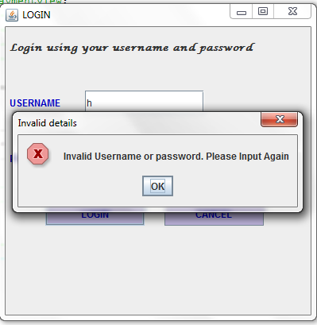

Figure : Access Denied! User privileges

### 

### 5.6.2 Form Validate

When the nurse is entering patient details, in case he/she fails to fill one field the application gives a notification to the user to fill the fields first before proceeding.

Figure : A partially filled form

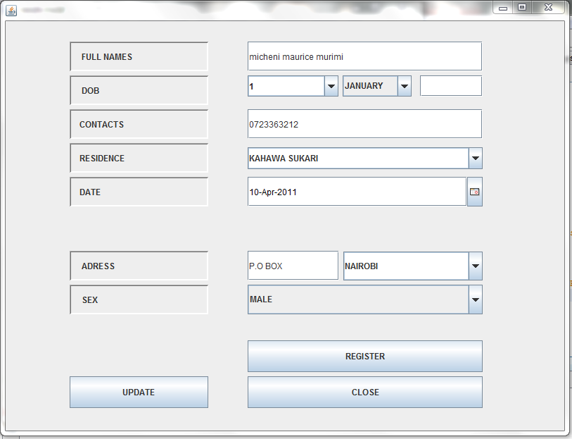

The above form has not been fully filled. The form validator is prompted and a pop up message box appears asking the user to fill all fields before saving the records. The pop up message box is shown below.

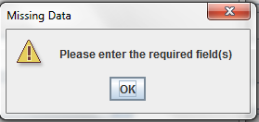

Figure : Form validation in action

# CHAPTER 6

## Appendices

### 6.1 Questionnaires

I’m a student of Jomo Kenyatta University of Agriculture and Technology, Department of Information Technology and main campus-Juja and presently doing a project on “Implementing security in health System”. I request you to kindly fill the questionnaires below and assure you that the data generated shall kept confidential.

**PART A**

**Please answer the questions on the basis of your personal opinions, experience or professionalism and without altering the reality of the issue in question.**

1. What are the objectives of the health clinic?

……………………………………………………………………………………….

1. What is the average number of patients that the clinic receives on daily basis?

…………………………………………………………………………………….

1. Other than booking what are other services offered by the clinic?

…………………………………………………………………………………

1. Describe the organizational structure of the health clinic

…………………………………………………………………………………….

1. Describe the current management system in use in terms of its performance?

…………………………………………………………………………………….

1. What are the major shortcomings with the current health system?

………………………………………………………………………………………

1. What outputs are needed at the management level and how are the outputs obtained?

....................................…………………………………………………………….

**PART B.**

1. How would you describe the current system? (Tick one)

* Easy to work with
* Complex
* Relatively easy
* No idea/cannot describe

2. Do you like the current system? (Tick one)

* Yes
* No
* moderately

3. Can you rate the efficiency of the current system? (Tick one)

* 20-40% efficient
* 41-60% efficient
* 61-80% efficient
* 81-95% efficient

4. Would you like an upgrade of the current system? (Tick one)

* Yes
* No
* Moderately

5. What type of system is used in the health clinic? (Tick one)

* Computerized system
* Manual system

6. Which kind of system you would like developed (Tick one)

* Distributed
* Full computerized
* Partially computerized

7. How fast is the current system in processing reports used by the company?

* fast
* moderate
* slow
* very slow

### 6.2 Budget

|  |  |  |  |  |  |
| --- | --- | --- | --- | --- | --- |
| **NO** | **ITEM** | **DESCRIPTION** | **UNIT PRICE(KSH)** | **QUANTITY** | **COST (KSH)** |
| 1. | Backup CDs |  | 30 | 3 | 90 |
| 2. | Flash disk |  | 850 | 1 | 850 |
| 4. | Stationaries | Pens  Printing Papers | 300 | 1 | available  300 |
| 5. | Printer |  |  |  | 2000 |
| 6. | Computer |  |  |  | Available |
| 7. | Software   1. Antivirus 2. Ms office 3. Dreamweaver package 4. Operating System | Avast  Version 7.0    Windows 7 |  | 1  1  1  1 | 1000  available  1500  Available |
| 8. | Miscellaneous |  |  |  | 1,500 |
| **Total** | | | | | **7740** |

### 6.3 Gantt chart

|  |  |  |  |  |  |  |  |  |  |  |  |  |  |
| --- | --- | --- | --- | --- | --- | --- | --- | --- | --- | --- | --- | --- | --- |
| Activities | **1** | **2** | **3** | **4** | **5** | **6** | **7** | **8** | **9** | **10** | **11** | **12** | **13** |
| Feasibility  study |  |  |  |  |  |  |  |  |  |  |  |  |  |
| Analysis |  |  |  |  |  |  |  |  |  |  |  |  |  |
| Database design |  |  |  |  |  |  |  |  |  |  |  |  |  |
| Interface design |  |  |  |  |  |  |  |  |  |  |  |  |  |
| Coding |  |  |  |  |  |  |  |  |  |  |  |  |  |
| Testing |  |  |  |  |  |  |  |  |  |  |  |  |  |
| Documentation |  |  |  |  |  |  |  |  |  |  |  |  |  |
| Implementation |  |  |  |  |  |  |  |  |  |  |  |  |  |

### User manual